LAB EXPERIMENT

SET 29: STUDENT ACADEMIC PERFORMANCE

Department | AIDS
Course Code / Course Name | DSA0602 / Data Handling and Visualization
Experiment | Data Visualization using R and Tableau
Name | D.HEMASREE
Register Number | 192524114
Date | 22 October 2026
Day | Thursday

Aim
To analyze student academic performance data using a stacked area chart, a boxplot and a density plot in R, and to build an interactive scatter plot in Tableau. Dataset: Student Academic Performance

Student_ID | Age | Study_Hours | Attendance (%) | Test_Score | Participation_Score
S1 | 19 | 12 | 90 | 85 | 8
S2 | 21 | 8 | 70 | 70 | 7
S3 | 20 | 15 | 95 | 92 | 9
S4 | 22 | 10 | 85 | 80 | 8
S5 | 23 | 7 | 60 | 65 | 6

PROGRAM 1: Stacked Area Chart of Test Score and Participation Score
Using R, create a stacked area chart showing Test_Score and Participation_Score across students. Analyze trends.
library(ggplot2)

students <- data.frame(
Student_ID
Age Study_Hours Attendance Test_Score
= c("S1", "S2", "S3", "S4", "S5"),
= c(19, 21, 20, 22, 23),
= c(12, 8, 15, 10, 7),
= c(90, 70, 95, 85, 60),
= c(85, 70, 92, 80, 65),
Participation_Score = c(8, 7, 9, 8, 6)
)

long_scores <- data.frame( student = rep(1:5, times = 2),
measure = rep(c("Test_Score", "Participation_Score"), each = 5), score = c(students$Test_Score, students$Participation_Score)
)

ggplot(long_scores, aes(x = student, y = score, fill = measure)) + geom_area() +
scale_x_continuous(breaks = 1:5, labels = students$Student_ID) + labs(title = "Test Score and Participation Score Across Students",

x = "Student", y = "Score",
fill = "Measure")

OUTPUT:

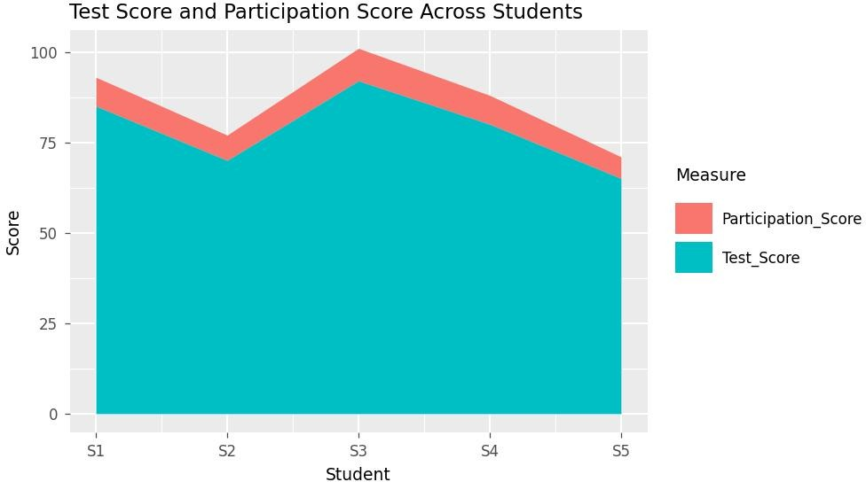

Output 1: Test Score and Participation Score Across Students (Stacked Area Chart)

Observation:
Test_Score and Participation_Score rise and fall together across the students. S3 has the highest values (92 and 9), which gives the tallest stack of 101, and S5 has the lowest values (65 and 6), which gives the lowest stack of 71. Test_Score dips from 85 at S1 to 70 at S2, peaks at S3, then falls steadily through S4 (80) to S5
(65). Participation_Score stays within a narrow range of 6 to 9, so Test_Score forms most of each stack. The trend shows that students with higher participation also score higher in the test.

PROGRAM 2: Boxplot of Study Hours by Attendance Quartile
Using R, generate a boxplot of Study_Hours grouped by Attendance quartiles. Include axis labels, title and colors for each quartile. Interpret patterns and identify the median, interquartile range and any outliers.
library(ggplot2)

students <- data.frame(
Student_ID
Age Study_Hours Attendance Test_Score
= c("S1", "S2", "S3", "S4", "S5"),
= c(19, 21, 20, 22, 23),
= c(12, 8, 15, 10, 7),
= c(90, 70, 95, 85, 60),
= c(85, 70, 92, 80, 65),
Participation_Score = c(8, 7, 9, 8, 6)
)

students$Attendance_Quartile <- cut( students$Attendance,
breaks = quantile(students$Attendance, probs = seq(0, 1, 0.25)), include.lowest = TRUE,

labels = c("Q1 (Lowest)", "Q2", "Q3", "Q4 (Highest)")
)

ggplot(students, aes(x = Attendance_Quartile, y = Study_Hours,
fill = Attendance_Quartile)) +
geom_boxplot() +
scale_fill_manual(values = c("#4E79A7", "#F28E2B", "#59A14F", "#E15759")) + labs(title = "Study Hours by Attendance Quartile",
x = "Attendance Quartile", y = "Study Hours") +
theme(legend.position = "none")

tapply(students$Study_Hours, students$Attendance_Quartile, median) boxplot.stats(students$Study_Hours)$out

OUTPUT:

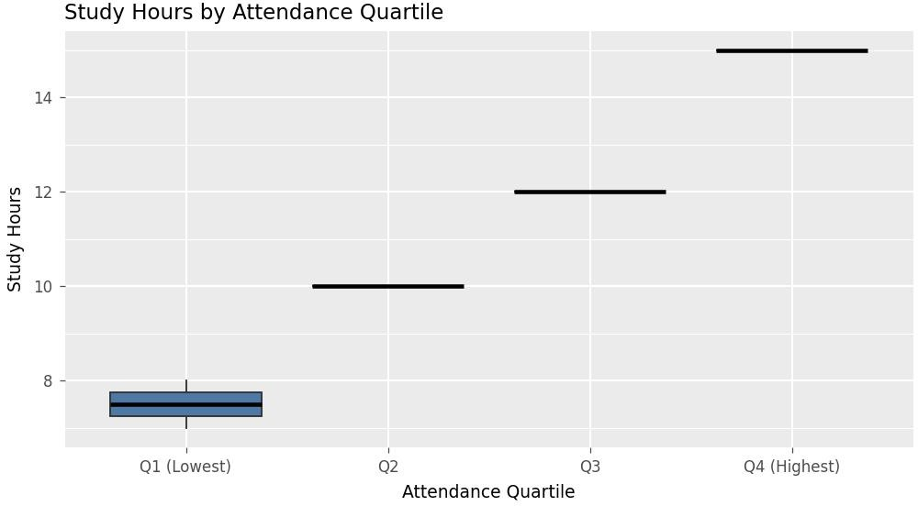

Output 2: Study Hours by Attendance Quartile (Boxplot)

Q1 (Lowest) | Q2 | Q3 Q4 (Highest)
7.5 | 10.0 | 12.0 15.0
numeric(0)

Observation:
The attendance quartile boundaries are 60, 70, 85, 90 and 95. The median study hours increase with every quartile: 7.5 for Q1, 10 for Q2, 12 for Q3 and 15 for Q4. This shows that students with higher attendance also study for more hours. Q1 holds two students (7 and 8 hours), so it is the only quartile with a visible box; the other quartiles hold one student each, so the box shrinks to a single line. For all students, the median study time is 10 hours and the interquartile range is 8 to 12 hours (IQR = 4). The outlier fences are 2 and 18 hours, and every value lies between 7 and 15, so there are no outliers in study hours.

PROGRAM 3: Density Plot of Test Score
Using R, construct a density plot for Test_Score to evaluate score distribution and outliers.
library(ggplot2)

students <- data.frame(
Student_ID
Age Study_Hours Attendance Test_Score
= c("S1", "S2", "S3", "S4", "S5"),
= c(19, 21, 20, 22, 23),
= c(12, 8, 15, 10, 7),
= c(90, 70, 95, 85, 60),
= c(85, 70, 92, 80, 65),
Participation_Score = c(8, 7, 9, 8, 6)
)

ggplot(students, aes(x = Test_Score)) + geom_density(fill = "steelblue", alpha = 0.5) + geom_rug() +
labs(title = "Density Plot of Test Score", x = "Test Score",
y = "Density")

summary(students$Test_Score) boxplot.stats(students$Test_Score)$out

OUTPUT:

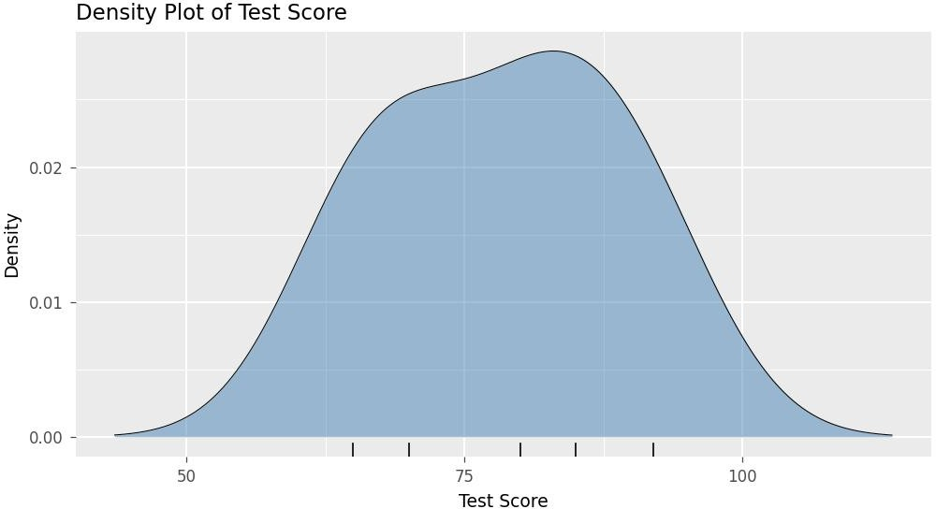

Output 3: Density Plot of Test Score
Min. 1st Qu. Median
Mean 3rd Qu.
65.0 70.0 80.0 78.4 85.0
Max.
92.0
numeric(0)

Observation:

Test scores range from 65 to 92 with a mean of 78.4, a median of 80 and a standard deviation of about 11. The curve is broad with one main peak near the median, and the mean being slightly below the median gives a mild tail towards the lower scores. The first and third quartiles are 70 and 85 (IQR = 15), so the outlier fences are 47.5 and 107.5. All scores fall inside these limits, so there are no outliers. Since there are only five students, the shape of the curve is only indicative.

PROGRAM 4: Interactive Scatter Plot in Tableau
In Tableau, design an interactive scatterplot with Study_Hours on X-axis, Test_Score on Y-axis, colored by Participation_Score. Include filters for Age.

Steps in Tableau
- Save the data as an Excel or CSV file and connect to it in Tableau (Connect > Microsoft Excel / Text file). Check that Age, Study_Hours, Attendance, Test_Score and Participation_Score appear as measures.
- Open a new worksheet and rename it "Study Hours vs Test Score". Drag Study_Hours to Columns and Test_Score to Rows.
- Drag Student_ID to Detail on the Marks card so that each student is shown as a separate point. Change the Marks type to Circle and increase the Size.
- Drag Participation_Score to Color on the Marks card. Click Color > Edit Colors and choose a sequential palette so that higher participation appears darker.
- Drag Age to Filters, select All Values and click OK. Right-click the filter, choose Show Filter and set it to Range of Values or Single Value (Slider).
- Drag Student_ID, Age and Attendance to Tooltip so that the details of each student appear when the mouse is moved over a point. Add axis titles and set the sheet title to "Study Hours vs Test Score by Participation".
- Create a new dashboard (Dashboard > New Dashboard), set the size to Automatic and drag the worksheet onto it. Keep the Age filter and Participation_Score color legend visible, give the dashboard the title "Student Academic Performance Dashboard", and test the filter in Presentation Mode.

OUTPUT:
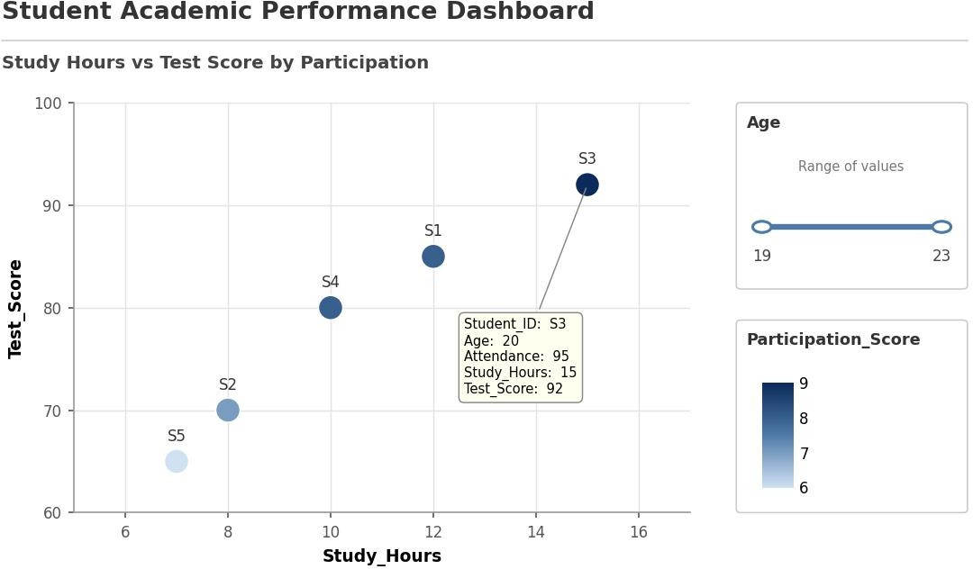

Output 4: Interactive Scatter Plot of Study Hours and Test Score (Tableau)

Observation:
The points rise from the lower left to the upper right, so students who study more hours score higher: 7 hours gives 65, 10 hours gives 80 and 15 hours gives 92. The darker points, which have higher Participation_Score, appear towards the upper right, so students with more study hours and higher participation also score higher. The Age filter (19 to 23) lets the viewer narrow the plot to selected age groups, and the tooltip shows the details of each student.

Procedure
- Create the student data frame in R with the columns Student_ID, Age, Study_Hours, Attendance, Test_Score and Participation_Score.
- Arrange Test_Score and Participation_Score in long format and use ggplot2 with geom_area() to draw the stacked area chart.
- Split Attendance into quartiles using cut() and quantile(), then use geom_boxplot() with scale_fill_manual() to draw the boxplot of Study_Hours.
- Use geom_density() to draw the density plot of Test_Score, and use summary() and boxplot.stats() to check the spread and outliers.
- Load the student file into Tableau and build the scatter plot with Study_Hours on X-axis, Test_Score on Y-axis and Participation_Score on Color.
- Add the Age filter and tooltip, then place the worksheet in a Tableau dashboard for interactive exploration.

RESULT:
The student academic performance data was successfully analyzed using a stacked area chart, a boxplot and a density plot in R. An interactive scatter plot with an Age filter was also created in Tableau, showing that higher study hours, attendance and participation go with higher test scores.

Key Functions and Tools Used

Function / Tool | Purpose
data.frame() | Creates the student dataset.
ggplot() / geom_area() | Creates the stacked area chart.
cut() / quantile() | Splits attendance into quartiles.
geom_boxplot() | Creates the boxplot of study hours by quartile.
boxplot.stats() | Finds the quartiles and any outliers.
geom_density() | Creates the density plot of test scores.
Tableau Scatter Plot | Shows Test_Score against Study_Hours colored by Participation_Score.
Tableau Filter | Filters the students by Age.

